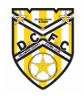DELAWARE COUNTY FUTBOL CLUB

Sponsorship Packet 2024

Email Contact: [dcfc.partner@gmail.com](mailto:dcfc.partner@gmail.com)

Website: [www.dcfcsoccer.org](http://www.dcfcsoccer.org)

**Our Values**

DCFC’s vision is to be more than just a soccer club. We want to build exceptional individuals, a healthier community, and a brighter future. We believe that the best way to do this is by teaching values through the sport of soccer. We hold honesty, teamwork, and personal responsibility in the highest regard. We compliment these moral values by teaching good health and learning habits, and physical, emotional, and psychological development. These standards set DCFC apart from other organizations.

**Our Program**

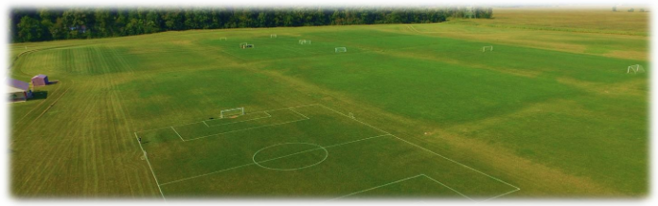DCFC takes pride in offering a wide range of services for people of all ages, genders, cultures, and activity levels. We offer a non-competitive, skill-building recreation program for children age 3-14, competitive travel leagues for players age 7-18, and an adult program for those who wish to continue playing recreationally after high school. For those who do not play our favorite game but still wish to be involved, we offer volunteer positions in administration, facility maintenance, and concession sales.

**Our Club**

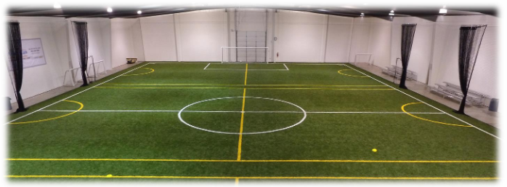The Delaware County Futbol Club (DCFC) was established in 2009 as the combination of the StarSoccer and Delaware County United soccer clubs. We are an affiliate of Indiana Soccer and a nonprofit 501c(3) organization. We have two (2) robust outdoor soccer facilities, one in Yorktown and the other at Heritage Hall that serve not only Delaware County, but the better part of East Central Indiana. We also have an indoor facility located at 5450 N Wheeling. These facilities help support our growing recreational, travel, and adult programs. DCFC believes that certain costs are necessary to support a competitive program but that they should never be a barrier to the wishes of any child. Therefore, DCFC also offers scholarships to make it possible for more children to play recreational and travel soccer. To support its growth and its goals, DCFC also reaches out with partnership and sponsorship opportunities to companies that we believe hold similar values.

*See next page for sponsorship opportunities*

DELAWARE COUNTY FUTBOL CLUB

Sponsorship Packet 2024

|  |  |  |  |  |  |
| --- | --- | --- | --- | --- | --- |
| **DCFC Partner**  **Packages** | **Cup** | **Region** | **MLS** | **Premier** | **World Cup** |
| **Sponsorship cost &**  **Contents:** | $500 | $750 | $1500 | $3000 | $10000 |
| **24” x 18” Logo Sign**  (Outdoor Locations) |  | check mark | check mark | check mark |  |
| **Logo distinction on DCFC Website**  **(Increased frequency with 1500 and up)** | check mark | check mark | check mark | check mark | check mark |
| **Social media write-ups**  (social media, website) | check mark | check mark | check mark | check mark | check mark |
| **Logo on back of Rec Shirts**  (Fall & Spring seasons ) |  |  |  |  | check mark |
| **Logo on**  **game day Shirts**  **For Travel teams** (with 3 yr commitment) |  |  |  |  | check mark |
| **Logo on back of Adult League Shirts** |  |  |  |  | check mark |
| **Large logo on front of Rec Shirts**  (Fall & Spring seasons) |  |  |  | check mark |  |
| **Indoor Logo Banner**  (‘The Cave’) |  |  | check mark | check mark |  |
| **Large Indoor Logo Banner**  (‘The Cave’) |  |  |  |  | check mark |
| **New building naming rights w/ large sign**  **( Yorktown Sports Park)** |  |  |  |  | check mark |

**\*\*Additional signage maybe available for various field sizes and locations**